
Acxiom Relational Database Offering & Transactions
Acxiom Relational Database Offering 1
BDF One Per 2
EBDF 2
Organizations Table 3
Groups Table 3
Index Table Description 4
Guidelines 6
BDF Transactions 8
EBDF Transactions 9

Acxiom Relational Database Offering
Acxiom provides the option for clients to utilize our business listings data in a relational database with more ease than when indexing flat file deliveries. The data is divided into a table structure with listings tied together by a Master Record ID. Listed below is a description of each table that we make available to clients so that you can choose what data is pertinent to your application.
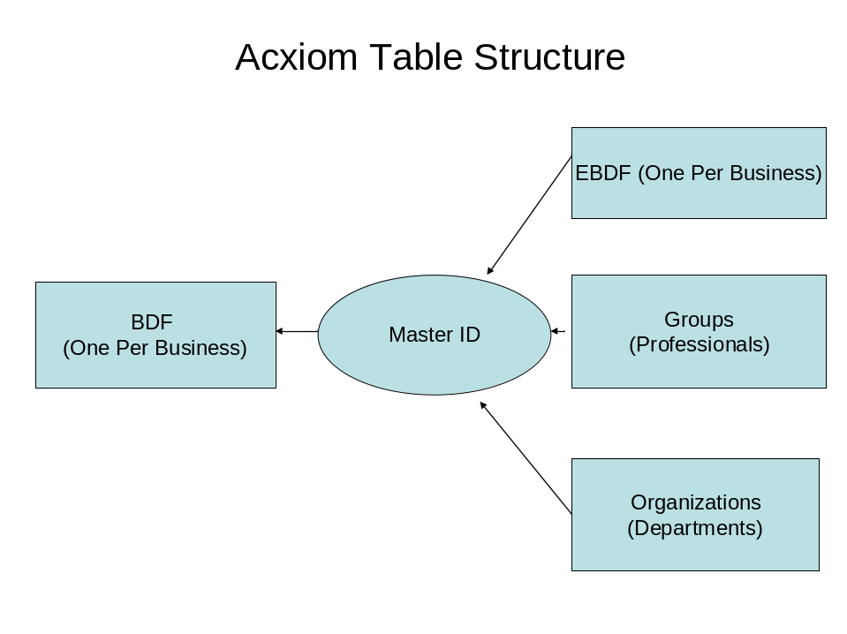
BDF One Per
Acxiom’s InfoBase-X Business Directory file contains approximately 12 MM records that are multi-sourced, which adds to the overall accuracy and coverage of the file. It is our belief that by compiling businesses from several sources, we provide you with the most comprehensive representation of businesses in the US. The BDF is what we call a One Per Business file as it contains just one representation of a business at a location. When a business does not have a street address populated, the listings will be netted based on the business name/phone number to determine unique businesses.
This is the primary file that all of the other tables tie into.
EBDF
Acxiom’s premium business profile database of approximately 5 million listings, collected from multiple sources, provides immediate access to key words and phrases associated with businesses throughout the United States. The base listings (Business name, address, phone, classification) in the EBDF are found in the BDF One per, but the rich business profiles are unique to this file. All records are tied back to the Acxiom national base listing file (BDF One Per) via a Master ID, so that a consumer requesting a specific business, product, or service will see only relevant companies within the search result.
Organization Table
The Organization table contains records that share a business name and address with a record in the BDF One Per file, where the phone number differs or where the department information is present. These records represent government offices, universities, hospitals and the like, where multiple departments exist at the same location, and where the information in the caption field can be used to identify the department represented by each record. This department information will reside on this table and link to the BDF One Per based on Master ID.
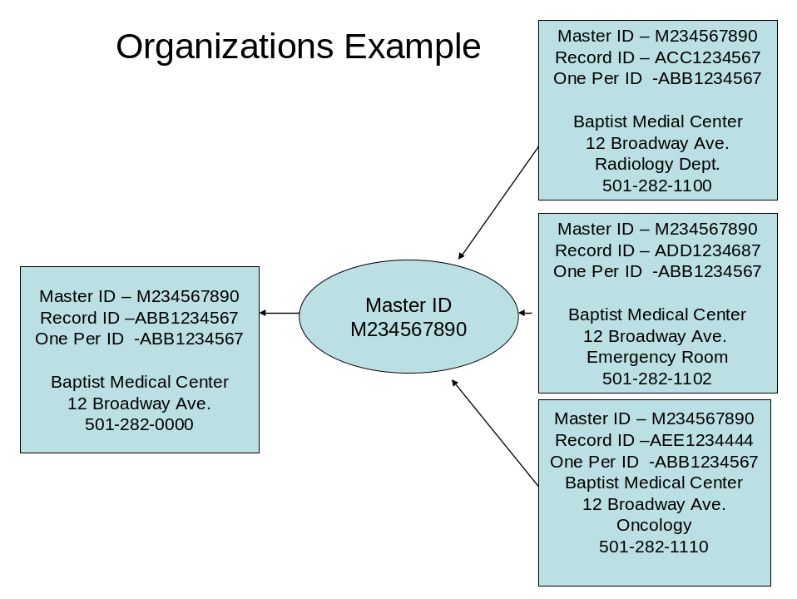

Group Table
The Group table separates the professional listings from the main listing for the company. These records share a strict address match (including suite number) and a business category match with a listing in the BDF One Per where the Business Name and the Phone Number are different. These groups represent law firms, insurance companies, medical practices, etc., where two or more professionals operate a common business. The listings in the Group tables will tie back to the main listing in the BDF One Per file via a Master Record ID.
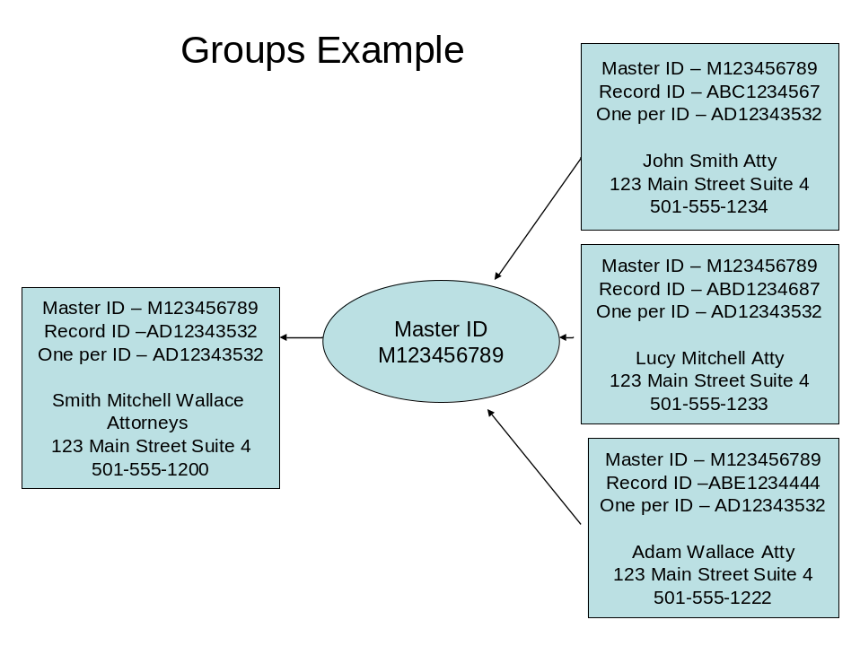

Index Table Description
With your order, you have the option of being provided with an Index Table. The Index will be your guide for sorting and grouping listings into your relational database. The Index allows you to sort the file based on Record ID. For each Record ID listed in the Index Table, a TRUE value in the One Per Flag, Organization Flag, Group Flag, or EBDF Flag column tells you where that record appears. This Index table allows you to keep all files separate or tie them together based on the Master Record ID, thus providing you with the flexibility to utilize elements in each file/table in conjunction with the others. Acxiom clients choose to have their data delivered in a flat file or in a database.
If you choose to receive transactional updates (adds, changes, deletes) instead of a Full File replacement in your contracted update schedule, then this Index Table will provide you with a File Maintenance flag that describes the type of change that has occurred, as well as a Change Code indicating the part of the record that has changed. Further information regarding transactional updates follows the overview of the Index.
Field Name | Description
Record ID | A BDF (Business Directory File) Record ID
One Per ID | The Record ID which represents the record in a set of records in the BDF One Per file (if present). When a Record ID belongs to a set of records (an organization or a group), the One Per ID indicates which record represents the set in the One Per file. If this Record ID is the representative record, the Record ID and One Per ID will be the same.
One Per Flag | TRUE indicates there is a record populated in the BDF One Per file with its own unique Record ID
Organization Flag | TRUE indicates there is a record populated in the Organizations Table with its own unique Record ID
Group Flag | TRUE indicates there is a record populated in the Groups Table with its own unique Record ID
EBDF Flag | TRUE indicates there is a record populated in the EBDF Table with a Record ID that is equal to the BDF One Per Record ID
Master Record ID | Master Record ID is populated on EVERY listing. In the case where there are multiple Record IDs that roll up to a set of records in the Organization and/or Group Tables, then a Master Record ID will represent the set of records. A set of records (an organization or a group) will all have the same Master Record ID.
File Maintenance Flag | Indicates the type of transaction (if any) associated with the Record ID. A=Add, C=Change, D=Delete, M=Move (Move from One Per to Groups, One Per to Orgs, or vice versa)  Note on ‘M’ – the M flag only appears in the Index file, while the other 3 flags appear directly in the BDF One Per, Groups, and Orgs. When a move occurs it is displayed as an ‘M’ in the Index, but it is displayed in the fields of the BDF as a ‘D’ from one table and an ‘A’ to the other.
Change Code | Indicates the group of elements in which a change occurred.  Level 1 - Street Number, Street Directional, Street Name, Unit Designator, Unit Number, City, State, Zip, Zip+4, and Vanity Listing.  Level 2 - If no transaction record changed in Level 1, then we look at Phone Code, Latitude, Longitude, Precision Code, FIPS, Caption 1-6, Caption Counter, Web Address, and Suppression Flag.  Level 3 - If no transaction record changed in Level 2, then we look at  SYPH 1-6, Primary SIC Flag, SIC 1-6, Primary NAICS Flag, NAICS 1-6, Primary SMCM Flag, and SMCM 1-6.  Level 4 – EBDF only – If no transaction record changed in Level 3, then we look at  EBDF fields with letter or year values: Ad Type, Ad Size, Credit Cards Accepted, Free Code, Hours, Language, Discount Code, Delivery Code, Year Started, Years In Business  Level 5 – EBDF only -- If no transaction record changed in Level 4 elements, then we look at EBDF fields with key word text values: Products, Products Synonyms, Brands, Brands Synonyms, Services, Services Synonyms, Models, Models Synonyms, Specialties, Specialties Synonyms, Programs Offered, Programs Offered Synonyms, Product Features, Product Features Synonyms, Service Features, Service Features Synonyms, Location Features, Location Features Synonyms, Groups Served, Groups Served Synonyms, Industry Type, Industry Type Synonyms, Special Considerations, Special Considerations Synonyms, Special Hours, Special Hours Synonyms, Ordering Methods, Ordering Methods Synonyms, Professionals On Staff, Professionals On Staff Synonyms, Payment Mode, Payment Mode Synonyms, Associations, Associations Synonyms, Certifications, Certifications Synonyms, General Content, General Content Synonyms.  Please note that in XML format, transactions marked as a change will only include elements that have changed.

Recommended Guidelines for Use of the Index Table
Although multiple publication options exist, the optimal scenario for a BDF / EBDF combined publication would be as follows:
- BDF One Per listings form the base data set for publication.
- Using the Index Table, the publisher looks for those Record IDs where additional data is available, in the form of supplementary business listings (the Organizations and Groups tables) or key words and phrases related to the business (the EBDF).
- Where additional data is found, either in the form of supplementary listings or key words and phrases, that data is linked to the BDF One Per listing for purposes of search and display.
What follows is a more detailed explanation of the Index Table that focuses on the above objectives.
- The records in the BDF One Per are the default base data set.
- For every record in the BDF One Per, there is a corresponding entry in the Index Table. These entries have the same values in Record ID and One Per ID. For these entries, the One Per Flag is set to True.
- The Organizations file contains all records that are members of an organization, aside from one record in the BDF One Per which acts as a representative record for that organization. The Index Table links records in the Organizations file with their representative records in the BDF One Per. For each record in the Organizations file, the Index Table will contain an entry with the Organizations Flag set to True. In this entry, the One Per ID will be the Record ID of the representative record in the One Per file. Additionally, the representative record in the One Per file and the linked records in the Organizations file all share the same Master Record ID.
- The Groups file is configured in the same manner as the Organizations file. For each record in the Groups file, the Index Table will contain an entry with the Groups Flag set to True. In this entry, the One Per ID will be the Record ID of the representative record in the One Per file. Additionally, the representative record in the One Per file and the linked records in the Groups file all share the same Master Record ID.
- Any BDF One Per record may have a corresponding record in the EBDF. The Record ID for the BDF record is the same as the Record ID for the corresponding EBDF record. Additionally, these records share the same Master Record ID. Any record that exists in EBDF will display True values in the index for the One Per Flag and for the EBDF Flag.
- When a record from the BDF One Per is incorporated for publication, the Index Table will act as a reference for discovering whether that record has a link to other records in the Organizations file or the Groups file, or to business profile content in the EBDF.
- Ideally, the data that records have in common will not be published in duplicate. With the BDF One Per file as the default data source, the publisher can make use of additional elements only from the linked Organizations, Groups, and EBDF records. For instance, the fields containing key terms and phrases may be the only elements from the EBDF record that make their way into publication. For an Organizations record, captions content and secondary phone numbers may be the only elements used. For a Groups record, the names of individual practitioners from the business name field and their specific phone numbers may be the only elements used. The goal is to provide rich additional content while avoiding redundancy.

BDF Transactions
The BDF Transactional Index is keyed on RecordID. This means that you should use RecordID to correlate the base data, the new data, and the index. MasterRecordID is a reference linking records together but does not provide a unique identifier for BDF.
In addition to the columns found in a standard Index file, the Transactional Index file contains a File Maintenance Flag column and a Change Code column. Note that the BDF layout also contains these columns, and that all data found in BDF transactional files is also found in the BDF Transactional Index. The format of the data differs slightly between the data files and the Transactional Index, as described below. It is advisable to use the Transactional Index as your guide when processing transactions.
The File Maintenance Flag column has four possible values. For each row, the given value relates to the RecordID in the RecordID column:
- If the record has been deleted there will be a 'D' in the File Maintenance Flag column.
- If the record has been added there will be an 'A' in the File Maintenance Flag column.
- If the record has been changed there will be a 'C' in the File Maintenance Flag column and the Change Code column will have the level of change.
- If the record has been moved from one BDF table to another there will be an ‘M’ in the File Maintenance Flag column. The Index will display the new location for the record, not the old location. For instance, an Index entry for a record that has moved from the One Per to the Groups table will have a “True” indicator in the Group Flag column and not in the One Per Flag column. Note that ‘M’ values appear only in the Transactional Index and not in the data files. The data files will contain two entries for each RecordID flagged with an ‘M’. The first entry, for the record in its old location, will have a ‘D’ in the File Maintenance Flag column. The second entry, for the record in its new location, will have an ‘A’ in the File Maintenance Flag column. These entries indicate that the record is to be removed from the first location (the One Per file in our example) and added to the second (the Groups file).
This is the order of operations for ease of implementing the transactional changes:
- For records marked ‘D’: Delete these records from your base data. The flag columns in the Transactional Index tell you where each record is located.
- For records marked ‘A’: Insert all records from the new data into your base data. The flag columns in the Transactional Index tell you to which file (One Per, Groups, or Orgs) each new record should be added to.
- For changed/updated records you have two options.
  - Full replace: Delete the rows in your old data where File Maintenance Flag is ‘C’. Insert all records (from the new data) into your base data where File Maintenance Flag is ‘C’.
  - Partial update: Compare using the Change Code column what has changed in the record. Then you can choose whether to replace the entire record or only certain data points.

EBDF Transactions
EBDF transactional updates always come with a file called the EBDF Index. The purpose of this file is to know which transactional records are adds, changes, or deletes. EBDF Index is keyed on MasterRecordID, a unique identifier for EBDF. This means that you should use MasterRecordID to correlate the base data, the new data, and the index.
- If the record has been deleted, the corresponding EBDF Index entry has a 'D' in the File Maintenance Flag column.
- If the record has been added, the corresponding EBDF Index entry has an 'A' in the File Maintenance Flag column.
- If the record has been changed, there will be a 'C' in the File Maintenance Flag column and Change Code will have the level of change.
To update your data using the files provided for transactions, first import the EBDF Index table and the EBDF records file into a database environment. If you receive SQL deliveries from Acxiom this would mean mounting the databases.
This is the order of operations for ease of implementing the transactional changes:
- For records marked ‘D’: Delete the rows in your base data where File Maintenance Flag in the index is ‘D’.
- For records marked ‘A’: Insert all records from the new data into your base data where File Maintenance Flag in the index is ‘A’.
- For changed/updated records you have two options.
  - Full replace: First, delete the rows in your base data where File Maintenance Flag in the index is ‘C’. Secondly, insert all records from the new data into your base data where File Maintenance Flag in the index is ‘C’.
  - Partial update: Compare using the Change Cole column what has changed in the record. Then you can choose whether to replace the entire record or only certain data points.

